**Appendix Figures and Tables**

**Appendix Figure 1.** Data source description. (a) shows the same or similar posts may be published by different authors, (b) shows the same post may be published in both groups, (c) shows a real post in the full size (c-1) and in brief (c-2) that was crawled and processed through a data cleaning step (c-3), and (d) and (e) are the descriptions of the two groups as of December 2019.

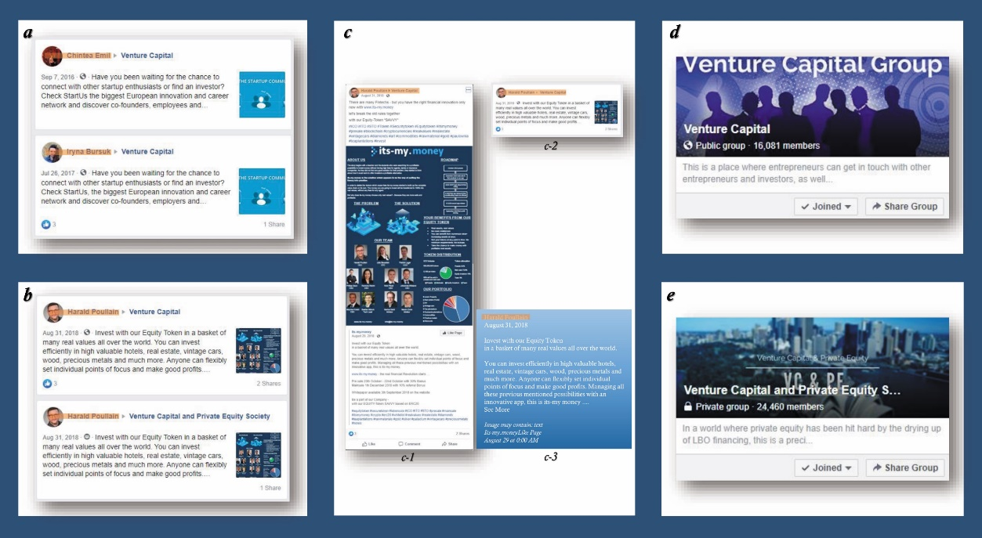

**Appendix Figure 2.** Understanding of methods. (a) is an illustration of the force-directed layout network, (b) illustrates a stream graph (*x*-axis = time, *y*-axis = number of identified topics.

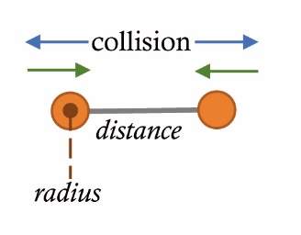 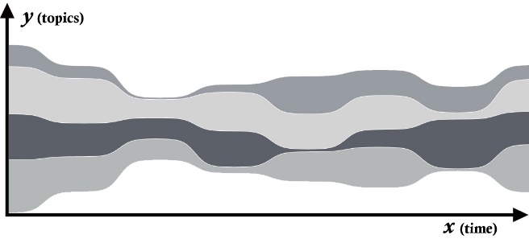

(a) (b)

**Appendix Table 1.** Moderator information for the two groups to indicate the sparsity of raw post data

|  |  |  |  |  |  |  |  |  |  |
| --- | --- | --- | --- | --- | --- | --- | --- | --- | --- |
| ***The Private group*** | | | | | ***The Public group*** | | | | |
| *Moderators* | *As an inviter* | *Posts* | *Followers* | *Got Likes* | *Moderators* | *As an Inviter* | *Posts* | *Followers* | *Got Likes* |
| S. Brian |  |  |  |  | 3Si MicroVentures | 204 |  | 1,370 | 1,331 |
| T. W. Byrd |  |  |  |  | C. Fernandes | 6,188 |  |  |  |
| M. H. Chew |  |  |  |  | J. Feimster | 2,567 | 512 | 1,239 |  |
| K. Chu |  |  |  |  |  |  |  |  |  |
| P. Dada |  |  | 204 |  |  |  |  |  |  |
| Y. Engelhard |  |  |  |  |  |  |  |  |  |
| J. Feimster | 2,453 |  | 1,239 | 2,453 |  |  |  |  |  |
| S. Garg |  |  | 62 |  |  |  |  |  |  |
| A. Grill |  |  | 62 |  |  |  |  |  |  |
| W. A. Hill | 11 | 1 |  | 11 |  |  |  |  |  |
| G. Horn |  |  |  |  |  |  |  |  |  |
| M. Kornak |  |  |  |  |  |  |  |  |  |
| J. L. D. Lee | 20 |  | 1,032 | 20 |  |  |  |  |  |
| J. Liu |  |  |  |  |  |  |  |  |  |
| G. Livingston |  |  |  |  |  |  |  |  |  |
| A. Mikhlin | 2 |  |  | 2 |  |  |  |  |  |
| K. Mller |  |  |  |  |  |  |  |  |  |
| R. Murphy |  |  |  |  |  |  |  |  |  |
| S. G. K. Naidu |  |  |  |  |  |  |  |  |  |
| A. Nathan |  |  |  |  |  |  |  |  |  |
| M. Porter |  |  |  |  |  |  |  |  |  |
| P. Sia |  |  |  |  |  |  |  |  |  |
| L. N. Timilsina |  |  |  |  |  |  |  |  |  |
| A. Todiwan |  |  | 96 |  |  |  |  |  |  |
| A. Zviagin |  |  |  |  |  |  |  |  |  |

**Appendix Table 2.** Example subgroups in two venture-capital groups.

|  |  |  |
| --- | --- | --- |
| Serial Number | ***The Private group*** | ***The Public group*** |
| 1 | J. Feimster, N. Jain, A. Jain | J. Feimster, W. J. D. West, A. Pedraza |
| 2 | J. C. Raymond, A. Bhatnagar, S. Jain | C. Fernandes, A. Shyamsukha, N. Hosabettu |
| 3 |  | C. Fernandes, K. Agrawal, V. Kumar |
| 4 |  | C. Fernandes, C. F. Foo, N. Eleftheriou |
| 5 |  | C. Fernandes, P. P. Gupta, A. Mishra |
| 6 |  | C. Fernandes, P. P. GuptaP, V. Kalwani |
| 7 |  | C. Fernandes, S. L. Vellaiyappan, R. Shankar |
| 8 |  | C. Fernandes, S. Katkar, M. Kumar |
| 9 |  | C. Fernandes, D. Yadav, R. Kumar |
| 10 |  | C. Fernandes, R. Pasari, A. Agarwal |
| 11 |  | C. Fernandes, S. Bandi, M. Sharma |
| 12 |  | C. Fernandes, V. Kumar, P. P. Paul |
| 13 |  | C. Fernandes, P. Seth, A. Gupta |
| 14 |  | C. Fernandes, P. Sharma, N. Arora |
| 15 |  | C. Fernandes, J. Cunniet, S. Khan |
| 16 |  | C. Fernandes, S. Jain, A. Arora |
| 17 |  | C. Fernandes, H. Kumar, A. Gupta |
| 18 |  | C. Fernandes, S. Anand, A. Kaushal |
| 19 |  | C. Fernandes, R. Jain, S. Singh |
| 20 |  | C. Fernandes, R. Sharma, D. Kumar |
| 21 |  | C. Fernandes, N. Murthy, R. Shankar |
| 22 |  | C. Fernandes, S. Singh, P. Kumar |
| 23 |  | C. Fernandes, A. Singh, A. Kumar |
| 24 |  | C. Fernandes, R. Thiruselvam, S. Claustan |
| 25 |  | C. Fernandes, Y. Rabinovich, C. C. Pepito |
| 26 |  | C. Fernandes, S. Mullick, A. Gupta |